Guidelines for Speed-Talk Presentations

- You are given 3 minutes for your presentation followed by 2 minutes for questions and discussion.
- Please note that the Speed-talk presentations will be evaluated by a panel of judges.
- Presentations which are longer or considerably shorter than the allocated time will be penalized by judges.
- Please prepare your video presentation and MS PowerPoint presentation by using the guidelines mentioned below (Template attached).
- All the speed-talk presenters are required to send a pre-recorded video presentation limited to 03 minutes. Presenters should participate in a live Q&A (2 minutes) session scheduled during the program.
- Please share your PowerPoint presentation (PDF file) and the recording (MP4) via the provided link on or before the deadline mention on the email. (https://forms.gle/8zHq2Wv6XqT3JQMG9)
- Please specify your particular Abstract ID (CMT ID) when uploading the video/presentation. (Ex: ST_CMT-001_YSCMR2023).

Guidelines for Speed talk presentation

- Presenters can have 3-5 slides (maximum 5 slides) and 3 minutes to explain the significance and breadth of their research to a non-specialist audience. The content of your presentation should be understandable by the educated general public.
- Please use the format below and the attached template to maintain consistency,
  - Font: Arial/Arial Black
  - Font Size: Main Topic 40
  - Font Size: Sub Topics 32-38
  - Font Size: Body Minimum 22
- The final version is to be saved as MP4.
- All speed talks should carry a recording (via Zoom) with 3 minutes which describes the slides (Follow the steps in Annexure 01).

Guidelines for recording

- Record MS PowerPoint slide show with vocal illustrations using Zoom technology (Follow the steps in Annex 01).
- All the recordings should be conducted in formal attire.
- Recordings should be carried out on a white background without backgrounddisturbances.
- Keep maximum volume during the recording.
- Make sure to maintain constant flow during the video preparation.
- An MP4 Landscape orientated full-screen view video is preferred.
- Please limit your video presentation to 3 minutes.

Annex 01
Video Recording Guidelines for Speed-talk Presentations

- All the speed-talk presenters are required to send a pre-recorded video presentation limited to 03 minutes. (You need to join the respective technical session on the conference day to be present at the question and discussion session).
- Please kindly use Zoom software for the video recording purpose to ensure consistency of presentations. Please let us know if you are using alternative softwarefor recording.

Recording a Zoom-Based Presentation

- Prepare your presentation using the PowerPoint template given on the conference web/attached herewith to this email.
- Create a Zoom account using https://zoom.us/, or if you already have one, log in toyour account with the Zoom app.
- Open your presentation and go to presentation mode.
- Go to the Zoom app and ‘Start New Zoom meeting’. Then, select ‘Join with computer audio’, unmute your microphone and turn ON the video camera icon at the left- bottom of your screen. (Not necessary to turn ON the camera for speed-talk presentations)
- In the Zoom toolbar, click the ‘Share Screen’ option and select the ‘Screen’ option. (You may click on your PowerPoint presentation to share your presentation).
- You will get your PowerPoint presentation through the Zoom window; minimize otherwindows opened, if any.
- If you have turned ON the camera, drag and drop your image onto the presentation's designated area, i.e., the right-top of the screen. When everything is ready, you should see a screen similar to the one below.
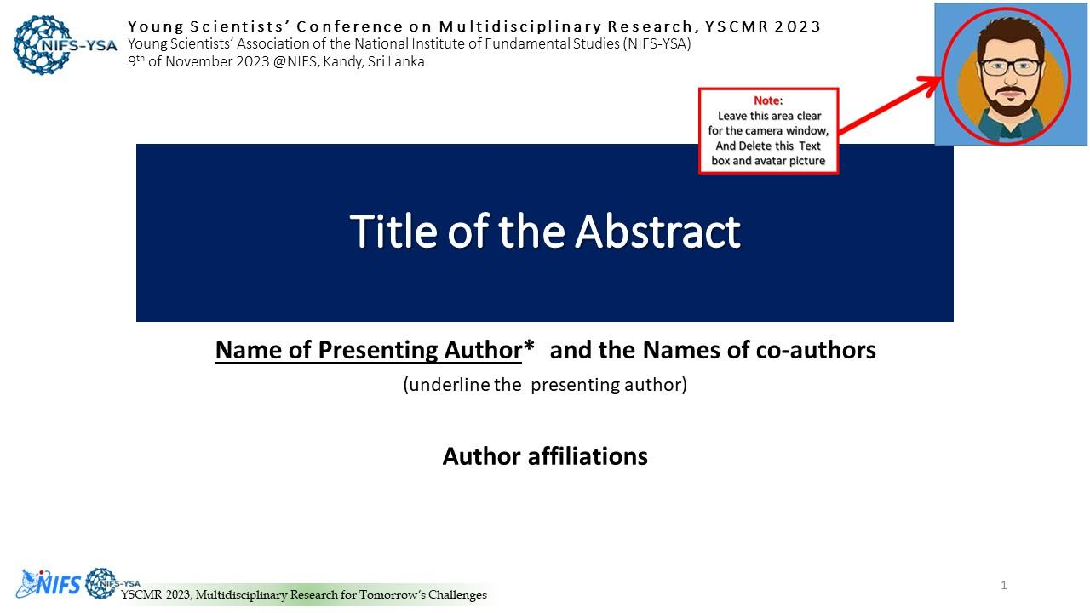

- Next, click ‘Record’ in Zoom (it may be under the ‘More’ button). You can also start recording by pressing the Alt+R keyboard shortcut. When you click ‘record, it will
begin recording; you may start to present your work. Make sure that the microphone is ON in the Zoom software.
- When the presentation is over, press the ‘Stop Recording’ button or the Alt+R key combination once more.
- Go to ‘More’ and click ‘end’. Then click on ‘Leave meeting for all ‘.
- Wait for the ‘Convert Meeting Record’ process to complete. It will be saved on your computer, and Zoom will open the recording folder after the video has been processed.

Note
  - Select a noise-free location with plain (white) background for your video recording.
  - Play and check your video before submitting us.
  - Kindly keep general ethics while selecting your attire.

Saving and submitting the presentation

- Go to the location of the video file. It is mandatory to save your recorded video presentation in MP4 format. Please rename your recording video by the abstract/paper ID number (CMT ID) before submitting (use the Paper ID number with 3digits).

Ex: ST_CMT-001_YSCMR2023

- Upload the MP4 version of your video presentation and the PDF version of your presentation slides to the https://forms.gle/8zHq2Wv6XqT3JQMG9 by the deadline mention on the email.

If you have any questions regarding these instructions, please email us at yscmr@nifs.ac.lk

