Young Scientists’ Conference on Multidisciplinary Research, YSCMR 2023 Organized by the Young Scientists’ Association
of the National Institute of Fundamental Studies, Sri Lanka (NIFS-YSA)
Guidelines for Oral Presentations
o You are given 8 minutes for your presentation followed by 2 minutes for questions and discussion.
o Please note that the oral presentations will be evaluated by a panel of judges. o Presentations which are longer or considerably shorter than the allocated time will be penalized by judges.
o Please prepare your video presentation and MS PowerPoint presentation by using the guidelines mentioned below (Template attached).
o All the oral presenters are required to send a pre-recorded video presentation limited to 08 minutes. Presenters should participate in a live Q&A (2 minutes) session scheduled during the program.
o Please share your PowerPoint presentation (PDF file) and the recording (MP4) via the provided link on or before the deadline mentioned in the email.
(https://forms.gle/8zHq2Wv6XqT3JQMG9)
o Please specify your particular Abstract ID (CMT ID) when uploading the video/ presentation. (Ex: ) OP_CMT-001_YSCMR2023
Guidelines for MS PowerPoint presentation
▪ Please use the format below to maintain consistency,
o Font: Arial/Arial Black
o Font Size: Main Topic 40
o Font Size: Sub Topics 32-38
o Font Size: Body Minimum 22
▪ Structure your presentation into the following sub-sections
o Introduction
o Objectives
o Methodology
o Results
o Discussion
o Conclusions
o Acknowledgement (If required)
o References
Guidelines for video presentations
o Record MS PowerPoint slide show with vocal illustrations using Zoom technology (Follow the steps in Annexure 01).
o All the recordings should be conducted in formal attire.
o Recordings should be carried out on a white background without
backgrounddisturbances.
o Keep maximum volume during the recording.
o Make sure to maintain constant flow during the video preparation.
o An MP4 Landscape orientated full-screen view video is preferred.
o Please limit your video presentation to 8 minutes.
Young Scientists’ Conference on Multidisciplinary Research, YSCMR 2023
Organized by the Young Scientists’ Association
of the National Institute of Fundamental Studies, Sri Lanka (NIFS-YSA)
Annex 01
Video Recording Guidelines for Oral Presentations
1. All the oral presenters are required to send a pre-recorded video presentation limited to 08 minutes. (You need to join the respective technical session on the conference day to be present at the question and discussion session).
2. Please kindly use Zoom software for the video recording purpose to ensure consistency of presentations. Please let us know if you are using alternative softwarefor recording.
Recording a Zoom-Based Presentation
1. Prepare your presentation using the PowerPoint template given on the conference web/attached herewith to this email.
2. Create a Zoom account using https://zoom.us/, or if you already have one, log in toyour account with the Zoom app.
3. Open your presentation and go to presentation mode.
4. Go to the Zoom app and ‘Start New Zoom meeting’. Then, select ‘Join with computer audio’, unmute your microphone and turn ON the video camera icon at the left bottom of your screen.
5. In the Zoom toolbar, click the ‘Share Screen’ option and select the ‘Screen’ option. (You may click on your PowerPoint presentation to share your presentation).
6. You will get your PowerPoint presentation through the Zoom window; minimize other windows opened, if any.
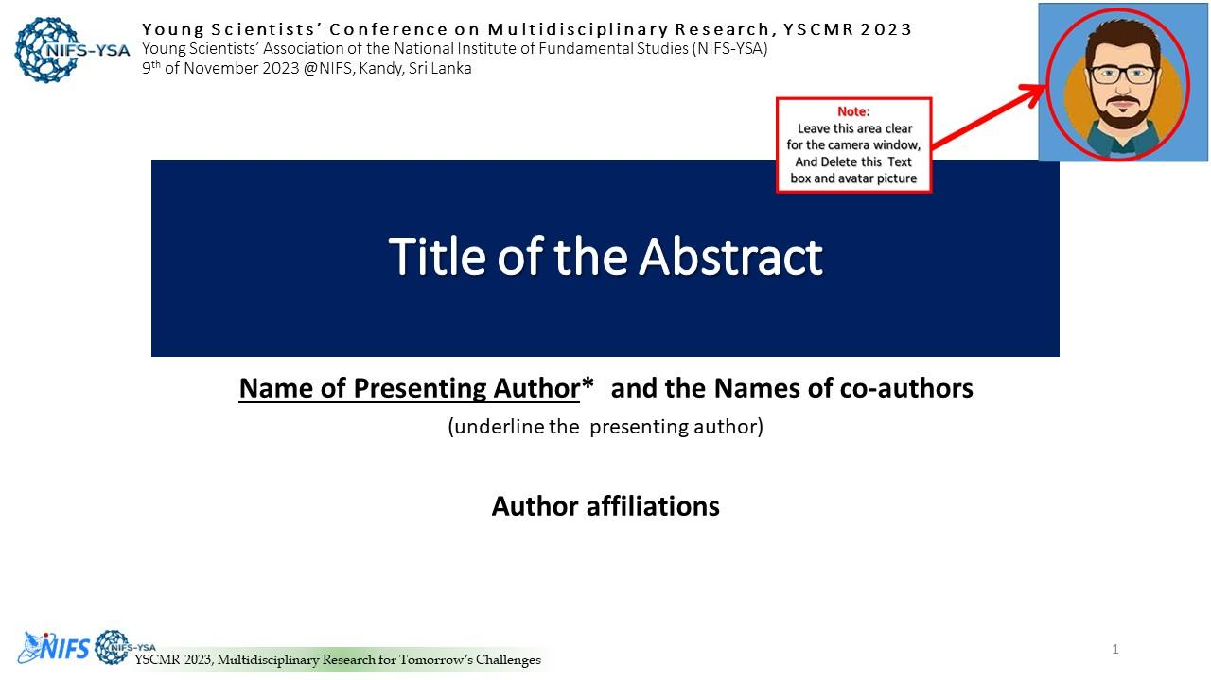
7. Drag and drop your image onto the presentation's designated area, i.e., the right-top of the screen. When everything is ready, you should see a screen similar to the one below.
8. Next, click ‘Record’ in Zoom (it may be under the ‘More’ button). You can also start recording by pressing the Alt+R keyboard shortcut. When you click ‘record, it will
Young Scientists’ Conference on Multidisciplinary Research, YSCMR 2023 Organized by the Young Scientists’ Association
of the National Institute of Fundamental Studies, Sri Lanka (NIFS-YSA)
begin recording; you may start to present your work. Make sure that the video camera and the microphone are ON in the Zoom software.
9. When the presentation is over, press the ‘Stop Recording’ button or the Alt+R key combination once more.
10. Go to ‘More’ and click ‘end’. Then click on ‘Leave meeting for all ‘.
11. Wait for the ‘Convert Meeting Record’ process to complete. It will be saved on your computer, and Zoom will open the recording folder after the video has been processed.
Note
1. Select a noise-free location with plain (white) background for your video recording. 2. Play and check your video before submitting us.
3. Kindly keep general ethics while selecting your attire.
Saving and submitting the presentation
1. Go to the location of the video file. It is mandatory to save your recorded video presentation in MP4 format. Please rename your recording video by the abstract/paper ID number (CMT ID) before submitting (use the Paper ID number with 3digits). Eg: OP_CMT-001_YSCMR2023
2. Upload the MP4 version of your video presentation and the PDF version of your presentation slides to the https://forms.gle/8zHq2Wv6XqT3JQMG9 by the deadline mentioned in the email.
If you have any questions regarding these instructions, please email us at yscmr@nifs.ac.lk

