Title of the abstract (Times New Roman, 14pt, Bold, centre aligned, max 20 words)

Introduction
The introduction section should include (1) the general background of the study (2) problem statement, scope and objectives of the study (3) a brief review of relevant literature, (4) outlined methodology, and (5) a conclusion of the major work.

Materials and Methods
The methodology must be explained in details and should be properly cited. The author must address the research question in precision, as well as discuss the research framework and methods used.

Results and Discussion
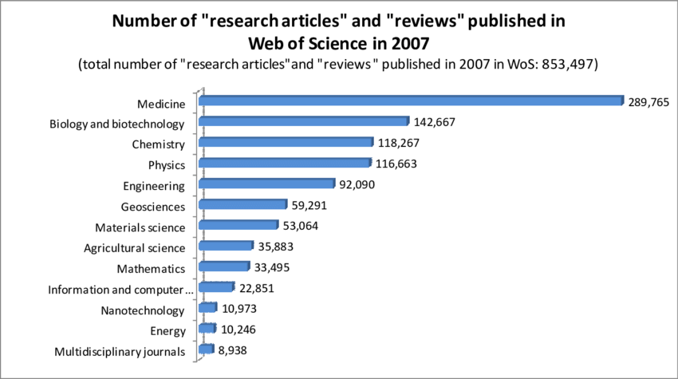
Provide a concise and precise description of the experimental results, their interpretation as well as the experimental conclusions that can be drawn. Tables, images, and figures should all be center-aligned. Figures or images should be numbered (Figure 1) and figure headers should be placed under each figure or image. As for the tables, they should also be numbered and the table header should be placed at the top. References (if any) of the tables, figures and images should be presented right under the tables, figures or images in the form of author surname and publication date.

Figure 1. Number of articles published in 2007

Conclusion(s)
Conclusions should include (1) the general findings inferred from the results, (2) any exceptions, problems or limitations of the work, (3) theoretical and/or practical implications of the work, including potential application or possible uses.

References
- Journal Article: Authors (year). Article title. Journal name in italics, volume in italics(issue not italics), page numbers. DOI.
Eg:
Ruxton, C. (2016). Tea: Hydration and other health benefits. Primary Health Care, 26(8), 34-42. https://doi.org/10.7748/phc.2016.e1162
- Book chapter (Print version): Authors (year). Title of chapter. In Editor(s) (Ed. OR Eds.), Title of book in italics (pp. page numbers). Place of publication: Publisher.

Eg:
Baker, F. M., & Lightfoot, O. B. (1993). Psychiatric care of ethnic elders. In A. C. Gaw (Ed.), Culture, ethnicity, and mental illness (pp. 517-552). Washington, DC: American Psychiatric Press.

- Book chapter (Electronic version): Authors (year). Title of chapter. In Editor(s) (Ed. OR Eds.), Title of book in italics (pp. page numbers). Retrieved from http: www.xxxxxx.
Eg:
Baker, F. M., & Lightfoot, O. B. (1993). Psychiatric care of ethnic elders. In A. C. Gaw (Ed.), Culture, ethnicity, and mental illness (pp. 517-552). Retrieved from http://www3.interscience.wiley.com/cgi-bin/bookhome/117909832.
- Web page: Authors or organization of page. (Year page created or revised). Title of page - italicise only if standalone document. Retrieved from http://www.xxxxxx
Eg:
Atherton, J. & Lightfoot, O. B (2005). Behaviour modification. Retrieved from http://www.learningandteaching.info/learning/behaviour_mod.html

