Title of the abstract (Times New Roman, 14pt, Bold, centre aligned, max 20 words)

Abstract
Body of the abstract: The abstract should not exceed 300 words and should be informative to cover background, objectives, methods, results and conclusion of the study. Please follow the guidelines given for structured abstract below. Do not include figures, graphs or citations within the abstract. Any submitted figures or graphs will not be published (Times New Roman, 12 pt, Justify aligned, maximum 300 words, single line spacing)

Keywords: Maximum of 5 keywords separated by coma (,) which best describe your study (font: Times New Roman, 12 pt, Italic, left aligned, lower case, arrange alphabetically). Do not include words from the title.

Acknowledgement: if needed, any grant/place which was supported to the research but not in the affiliations, only one. (Times New Roman, 11 pt, left aligned, lower case)

Introduction
The introduction section should include (1) the general background of the study (2) problem statement, scope and objectives of the study (2) a brief review of relevant literature, (3) outlined methodology, and (4) a conclusion of the major work.

Materials and Methods
The methodology must be explained in details and should be properly cited. The author must address the research question in precision, as well as discuss the research framework and methods used.

Results and Discussion
Provide a concise and precise description of the experimental results, their interpretation as well as the experimental conclusions that can be drawn. Tables, images, and figures should all be center-aligned and Figures and images should be numbered (Figure 1) and figure headers should be placed underthe figure or image; as forthetables, they should also be numbered and the table header should be placed at the top. References (if any) of the tables, figures and images should be presented right under the tables, figures and images in the form of author surname and publication date.

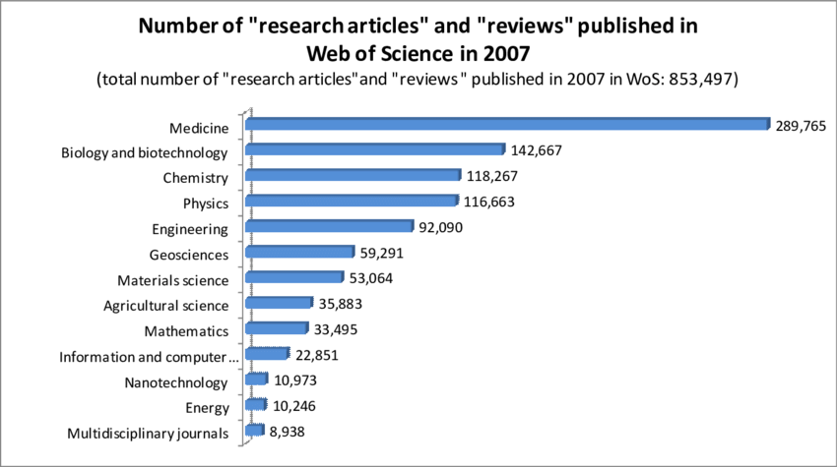
Figure 1. Number of articles published in 2007

Conclusion(s)
Conclusions should include (1) the principles and generalisations inferred from the results, (2) any exceptions, problems or limitations of the work, (3) theoretical and/or practical implications of the work, including potential market application and possible use, and (5) conclusions drawn and recommendations.

References
Madigan, R. J. (1995). The language of psychology: APA style as epistemology. American Psychologist, 50(6), 428
Mitchell, J.A. (2017). Citation: Why is it so important. Mendeley Journal, 67(2), 81-95. Retrieved from https://www.mendeley.com/reference-management/reference-manager
Jones, A.F & Wang, L. (2011). Spectacular creatures: The Amazon rainforest (2nd ed.). San Jose, Costa Rica: My Publisher
Mitchell, J.A. (2017, May 21). How and when to reference. Retrieved from https://www.howandwhentoreference.com

